Tutorial 2 – Test Plan & RTM
Screenshot Report
Field | Details
Website / Tool | Automation Exercise
URL | https://automationexercise.com
Module | Login / Registration
Student Task | Prepare a Test Plan and RTM for the Login/Registration module, then execute the 8 test cases.
Test Cases | Same TC IDs as the test case sheet: TC01 to TC08
Tester Name | Kothari Mann Jitendrakumar
Enrollment No | 2504030100433
Environment | Windows 10/11, Google Chrome (latest), internet connection

Test Case Execution

TC01 – Verify valid registration
TC ID | TC01
Test Case | Verify valid registration
Test Data | Name: Test User; Email: <your unique email>; Password: Test@1234
Expected Result | 'ACCOUNT CREATED!' message is displayed; after Continue the user is logged in
Actual Result | 'ACCOUNT CREATED!' displayed and user logged in
Status | PASS
Screenshot | 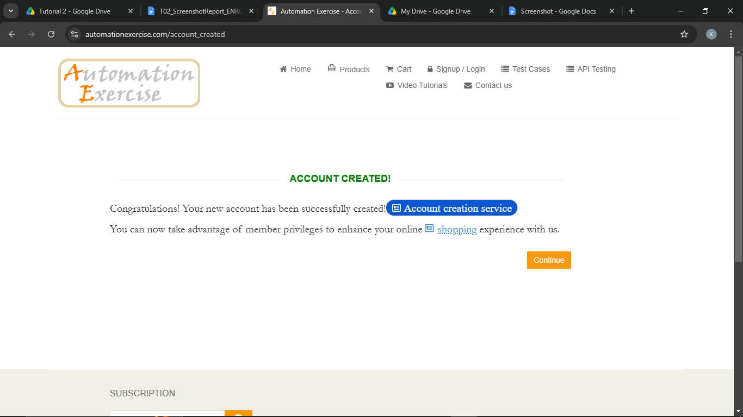
Defect ID | N/A

TC02 – Verify registration with an invalid email format
TC ID | TC02
Test Case | Verify registration with an invalid email format
Test Data | Name: Test User; Email: testuser.com
Expected Result | Browser validation asks for a valid email address and signup does not proceed
Actual Result | Validation tooltip shown, signup blocked
Status | PASS
Screenshot | 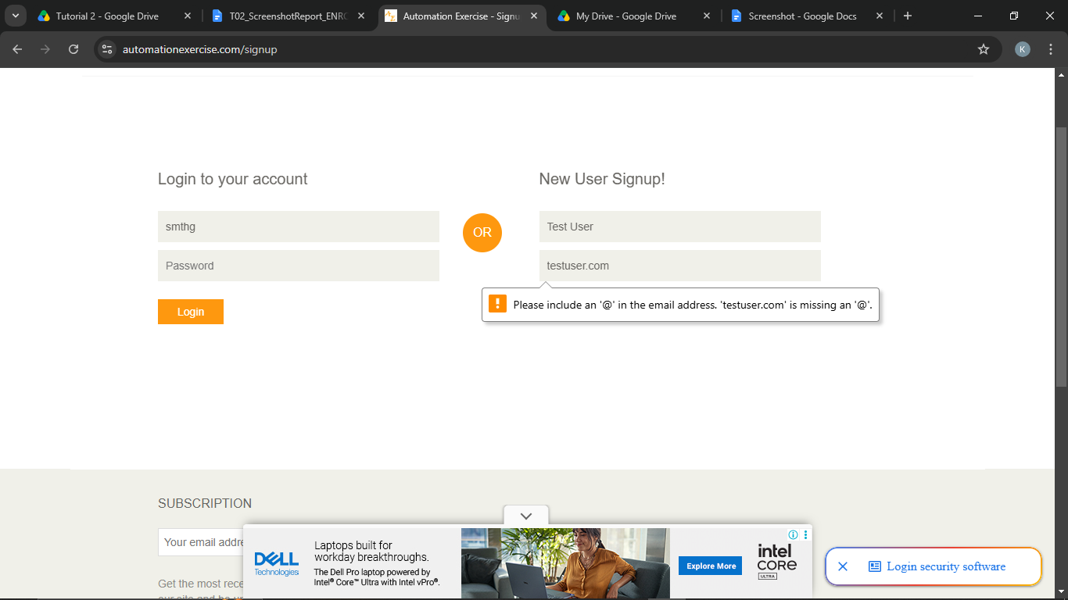
Defect ID | N/A

TC03 – Verify registration with an existing email
TC ID | TC03
Test Case | Verify registration with an existing email
Test Data | Name: Test User; Email: <email used in TC01>
Expected Result | Error 'Email Address already exist!' is displayed
Actual Result | Error 'Email Address already exist!' displayed
Status | PASS
Screenshot | 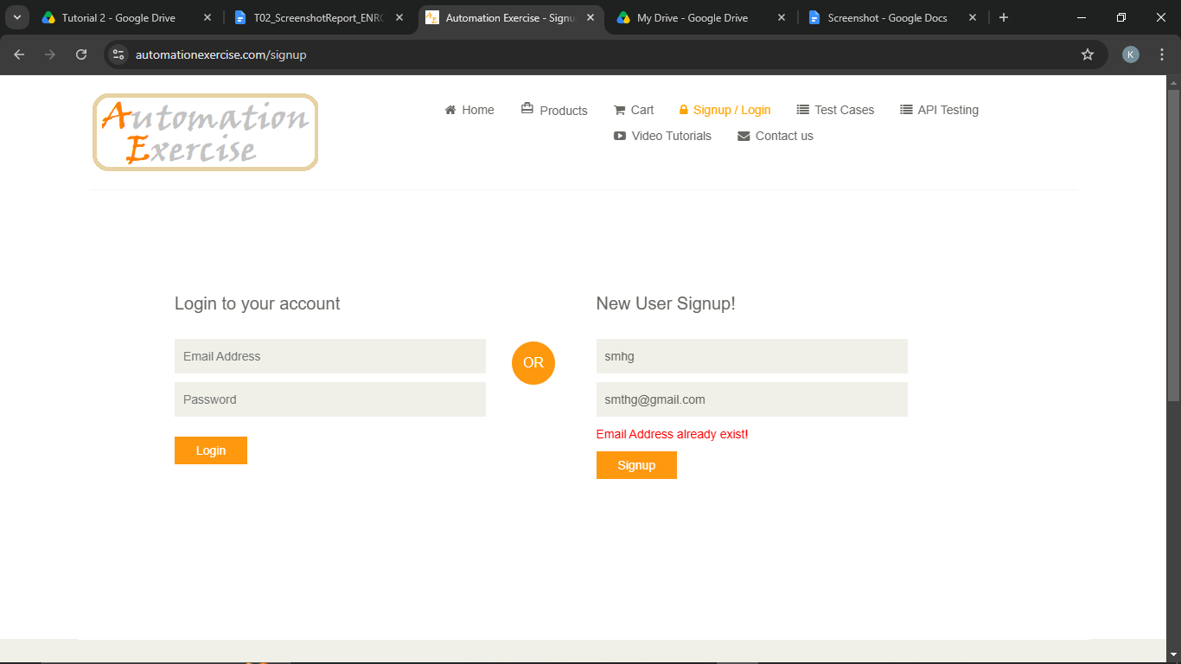
Defect ID | N/A

TC04 – Verify login with valid credentials
TC ID | TC04
Test Case | Verify login with valid credentials
Test Data | Email: <TC01 email>; Password: Test@1234
Expected Result | User is logged in; 'Logged in as <name>' appears in the header
Actual Result | 'Logged in as <name>' displayed
Status | PASS
Screenshot | 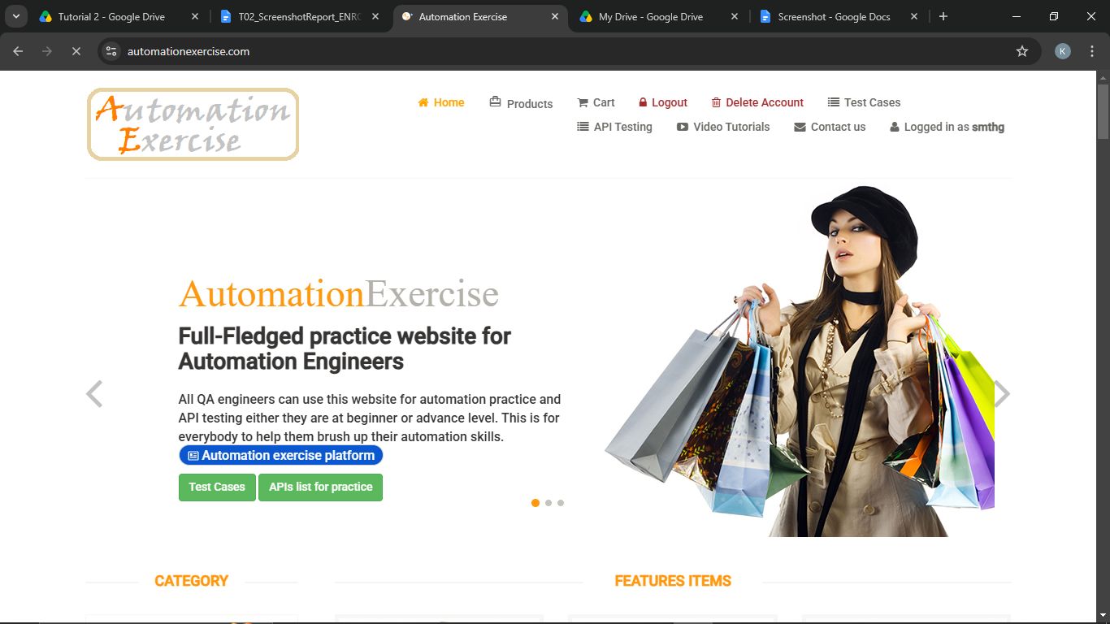
Defect ID | N/A

TC05 – Verify login with an invalid email
TC ID | TC05
Test Case | Verify login with an invalid email
Test Data | Email: wrong.user@example.com; Password: Test@1234
Expected Result | Error 'Your email or password is incorrect!' is displayed
Actual Result | Error message displayed
Status | PASS
Screenshot | 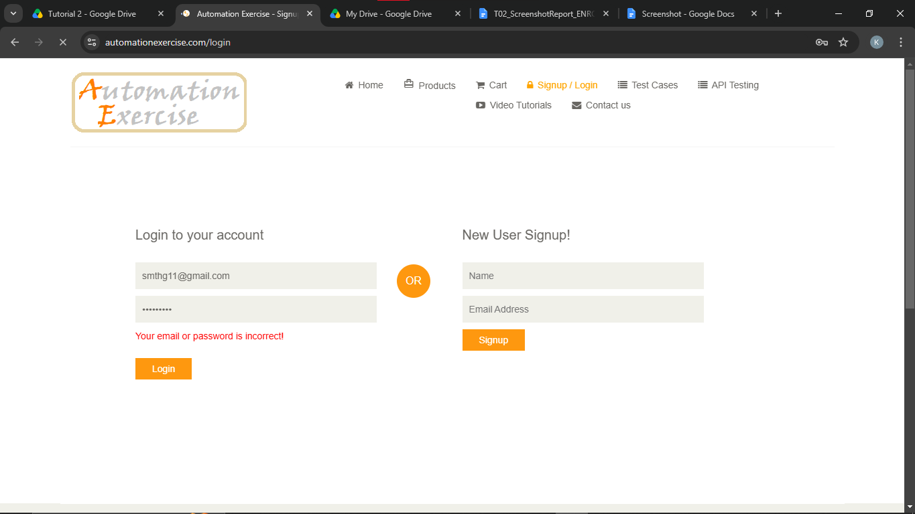
Defect ID | N/A

TC06 – Verify login with an invalid password
TC ID | TC06
Test Case | Verify login with an invalid password
Test Data | Email: <TC01 email>; Password: Wrong@123
Expected Result | Error 'Your email or password is incorrect!' is displayed
Actual Result | Error message displayed
Status | PASS
Screenshot | 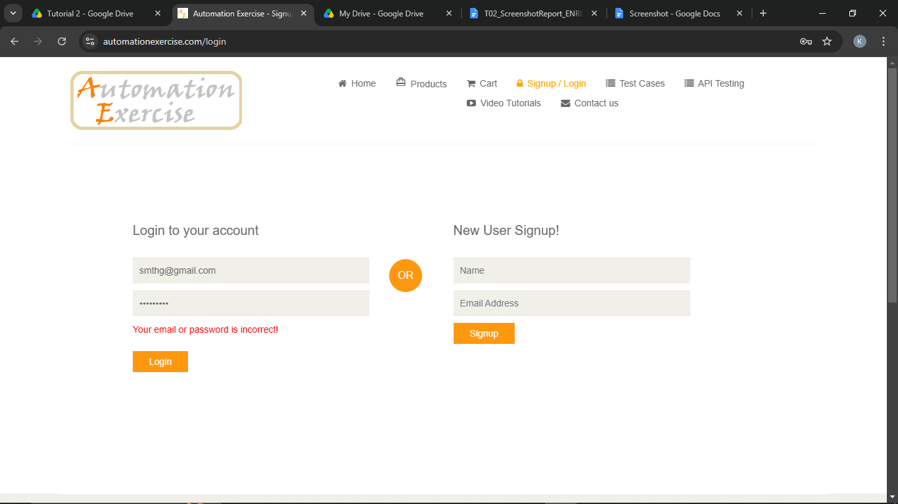
Defect ID | N/A

TC07 – Verify login with a blank username (email)
TC ID | TC07
Test Case | Verify login with a blank username (email)
Test Data | Email: (blank); Password: Test@1234
Expected Result | Browser message 'Please fill out this field.' is shown and login does not proceed
Actual Result | Validation tooltip shown, login blocked
Status | PASS
Screenshot | 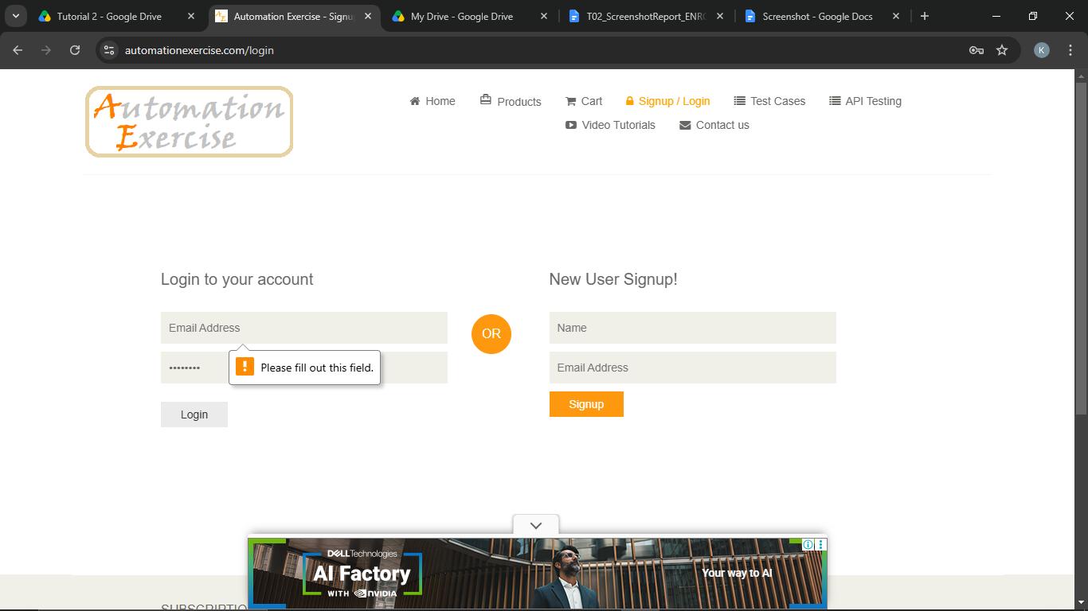
Defect ID | N/A

TC08 – Verify logout
TC ID | TC08
Test Case | Verify logout
Test Data | Valid credentials
Expected Result | User is returned to the Login page ('Login to your account')
Actual Result | Login page displayed after logout
Status | PASS
Screenshot | 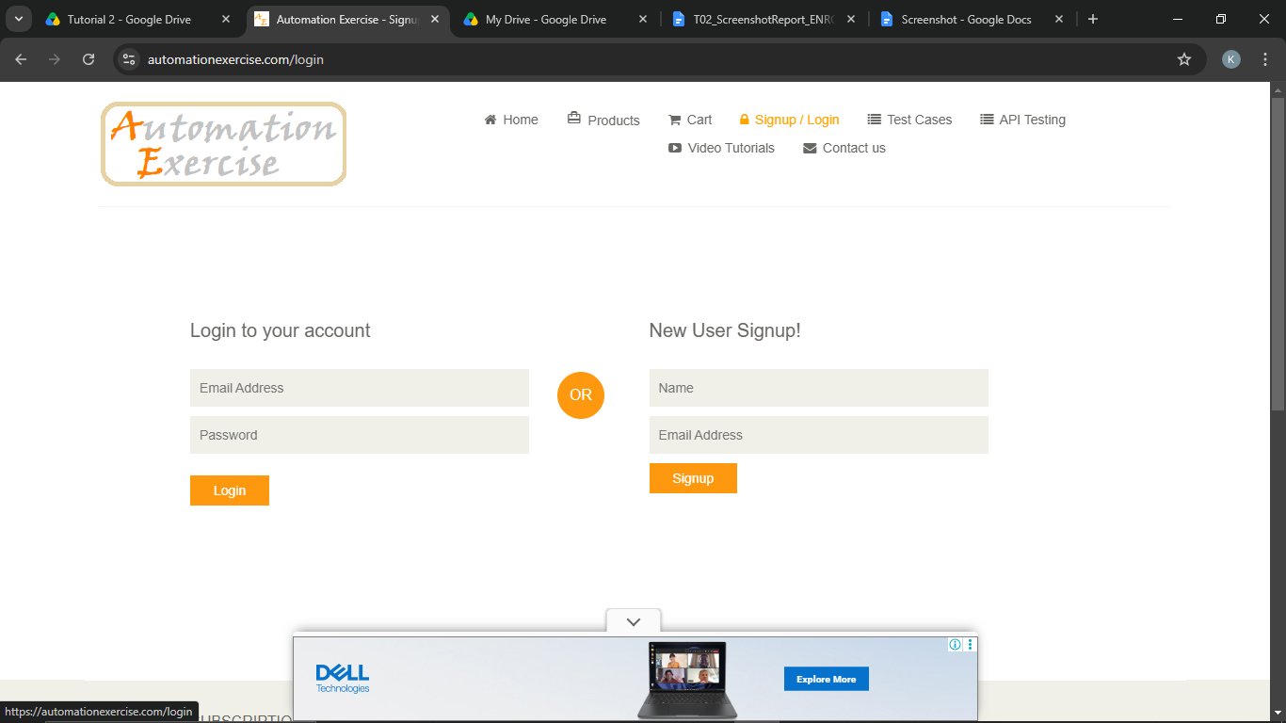
Defect ID | N/A

Test Plan
Section | Details
Objective | Verify the Login and Registration modules of Automation Exercise against the planned requirements.
Test Items | Signup, Login and Logout pages of https://automationexercise.com
Features to be tested | Valid/invalid registration, existing email, valid/invalid login, blank field validation, logout.
Features not to be tested | Products, cart, payment, contact-us, test-case page, API testing.
Test Approach | Manual black-box testing with positive and negative test cases; results documented with screenshots.
Test Environment | Windows 10/11, Google Chrome (latest), internet connection.
Test Data | Unique email + password Test@1234; invalid email formats; blank values.
Entry Criteria | Website reachable; test cases reviewed and approved.
Exit Criteria | All 8 test cases executed; defects logged; RTM shows every requirement covered.
Suspension Criteria | Website down or signup/login pages not loading.
Roles & Resources | Tester: [Your Name]
Schedule | Planning 1 day; Design 1 day; Execution 1 day; Reporting 1 day.
Risks | Public demo site may be slow/unavailable; test data may be reset.
Deliverables | Test plan, scope, strategy, RTM, test cases sheet, screenshot report.

Testing Scope Document
In Scope | Out of Scope
User registration | Product search and cart
User login | Payment and checkout
Logout | Performance and load testing
Field validation messages | Security penetration testing
Duplicate-email handling | API testing

Testing Strategy
Test Level / Type | Technique | Tool | Responsibility
System Testing | Black Box | Chrome browser | [Your Name]
Functional Testing | Equivalence Partitioning | Google Sheet test cases | [Your Name]
Negative Testing | Invalid / blank inputs | Chrome browser | [Your Name]
Regression Testing | Re-run of login cases | Google Sheet test cases | [Your Name]

Requirement Traceability Matrix (RTM)
Requirement ID | Requirement Description | Test Case ID | Status
R001 | A new user can register with valid details | TC01 | Pass
R002 | Invalid email format is rejected during signup | TC02 | Pass
R003 | An existing email cannot be registered again | TC03 | Pass
R004 | A registered user can log in with valid credentials | TC04 | Pass
R005 | Login is rejected for an invalid email | TC05 | Pass
R006 | Login is rejected for an invalid password | TC06 | Pass
R007 | Mandatory fields are validated | TC07 | Pass
R008 | A logged-in user can log out | TC08 | Pass

Test Execution Summary
Metric | Value
Total Test Cases | 8
Passed | 8
Failed | 0
Blocked | 0
Not executed yet (fill after running) | 0
Pass % | 100.0%

